**DAILY ONLINE ACTIVITIES SUMMARY**

|  |  |  |  |  |  |  |  |
| --- | --- | --- | --- | --- | --- | --- | --- |
| **Date:** | **20-7-2020** | | | | **Name:** | **Harshitha M** | |
| **Sem & Sec** | **8th sem A sec** | | | | **USN:** | **4al16cs038** | |
| **Online Test Summary** | | | | | | | |
| **Subject** | | **No Test** | | | | | |
| **Max. Marks** | |  | | **Score** | |  | |
| **Certification Course Summary** | | | | | | | |
| **Course** | **Machine Learning Foundation** | | | | | | |
| **Certificate Provider** | | | **Great learning academy** | **Duration** | | | **3.0hr** |
| **Coding Challenges** | | | | | | | |
| **Problem Statement:** **1**. **to read the number and compute the series.**  **2. to count the number in th series.**  **3. to check whether number is palindrome or not.**  **4. to find the number between 0 and 50 which are not divisible by 2 and 3.**  **5.micro and array update**  Top of Form | | | | | | | |
| **Status:completed** | | | | | | | |
| **Uploaded the report in Github** | | | | **yes** | | | |
| **If yes Repository name** | | | | **Harshitha-M** | | | |
| **Uploaded the report in slack** | | | | **yes** | | | |

**Online test**

No Test

**Certification course**

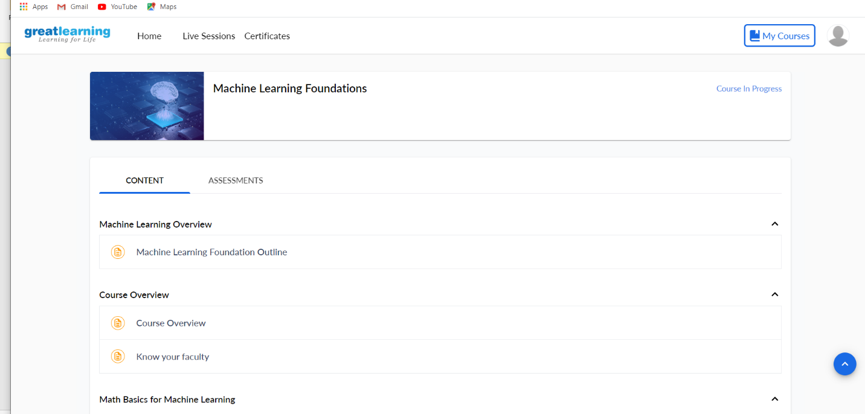

Coding

|  |  |
| --- | --- |
|  |  |

**l**import java.util.Scanner;

public class Demo {

public static void main(String[] args) {

/* This reads the input provided by user

* using keyboard

*/

Scanner scan = new Scanner(System.in);

System.out.print("Enter any number: ");

// This method reads the number provided using keyboard

int num = scan.nextInt();

// Closing Scanner after the use

scan.close();

// Displaying the number

System.out.println("The number entered by user: "+num);

}

}